**DAILY ONLINE ACTIVITIES SUMMARY**

|  |  |  |  |  |  |  |  |  |
| --- | --- | --- | --- | --- | --- | --- | --- | --- |
| **Date:** | **27/07/2020** | | | | | **Name:** | **NAIPUNYA VINOD NAIK** | |
| **Sem & Sec** | **IV SEM & A SECTION** | | | | | **USN:** | **4AL18CS050** | |
| **Online Test Summary** | | | | | | | | |
| **Subject** | | **DESIGN AND ANALYSIS OF ALGORITHMS DESCRIPTIVE TEST-2** | | | | | | |
| **Max. Marks** | | **30** | | **Score** | | | **-----------------------** | |
| **Certification Course Summary** | | | | | | | | |
| **Course** | 1. **GOOGLE CLOUD PLATFORM BIG DATA AND MACHINE LEARNING FUNDAMENTALS.** | | | | | | | |
| **Certificate Provider** | | | **COURSERA** | | **Duration** | | | **2 WEEKS** |
| **Coding Challenges** | | | | | | | | |
| **Problem Statement: NO PROBLEM STATEMENT** | | | | | | | | |
| **Status:----------------------** | | | | | | | | |
| **Uploaded the report in Github** | | | | | **YES** | | | |
| **If yes Repository name** | | | | | <https://github.com/naipunya-naik/daily-progress-report> | | | |
| **Uploaded the report in slack** | | | | | **YES** | | | |

Online Test Details: (Attach the snapshot and briefly write the report for the same).

TODAY DESIGN AND ANALYSIS OF ALGORITHMS DESCRIPTIVE TEST -2 WAS CONDUCTED ON 27 JULY 2020.

* SUBJECT:- DESIGN AND ANALYSIS OF ALGORITHMS
* CONDUCTED BY:- MS.MEGHA.D.HEGDE
* FROM 9.30 AM TO 11.00 AM
* DURATION:- 1.5 HRS
* NO.OF QUESTIONS:- 4
* TOTAL MARKS:- 30
* MARKS WILL BE PROVIDED SOON
* 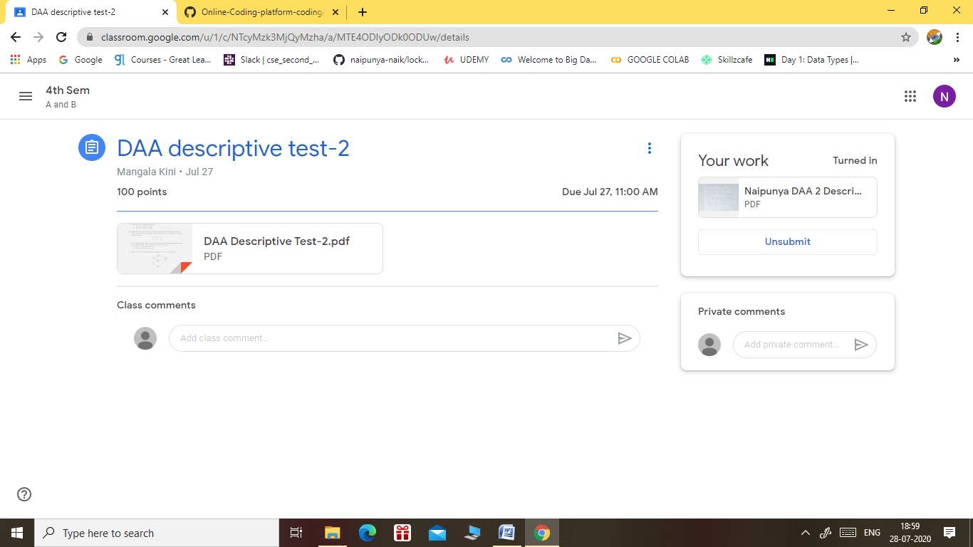

Certification Course Details: (Attach the snapshot and briefly write the report for the same).

CERTIFICATION COURSE NAME:- **GOOGLE CLOUD PLATFORM BIG DATA AND MACHINE LEARNING FUNDAMENTALS.**

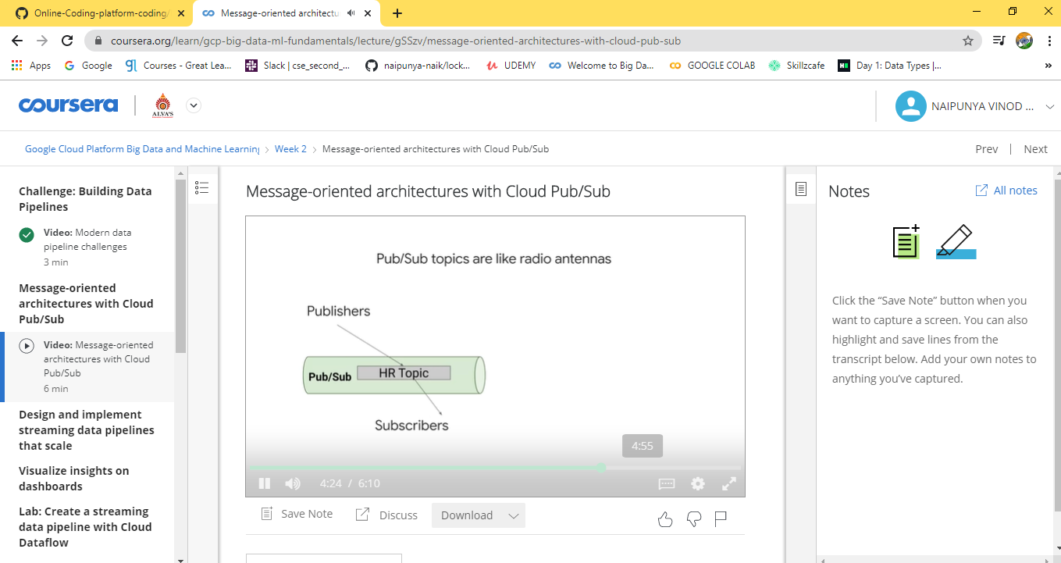

Coding Challenges Details: (Attach the snapshot and briefly write the report for the same).

NO PROBLEM STATEMENT GIVEN TODAY.